Yunlu Li (yl4df)

STAT 5120

Homework 3

1. (a) The constant variance assumption seems to be violated. There are some outliers: some patients stay very long.

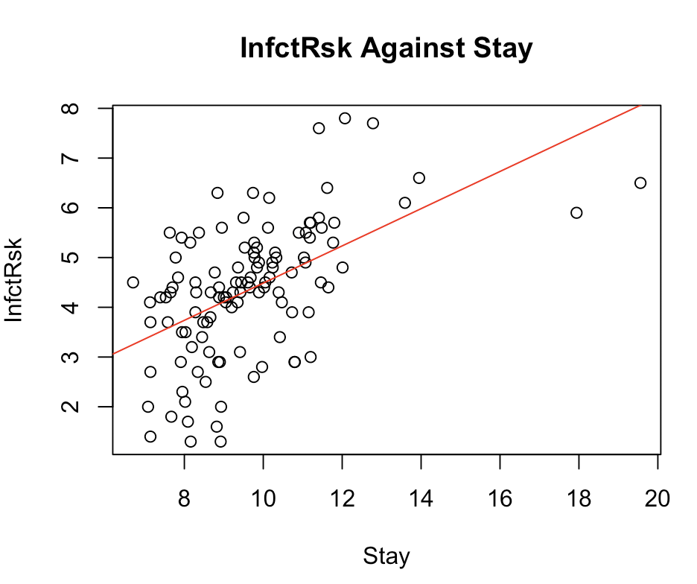

(b) The residuals fall in a horizontal band around 0 with no apparent pattern, but they do not have similar variation for different fitted values, so the constant variance assumption is violated.

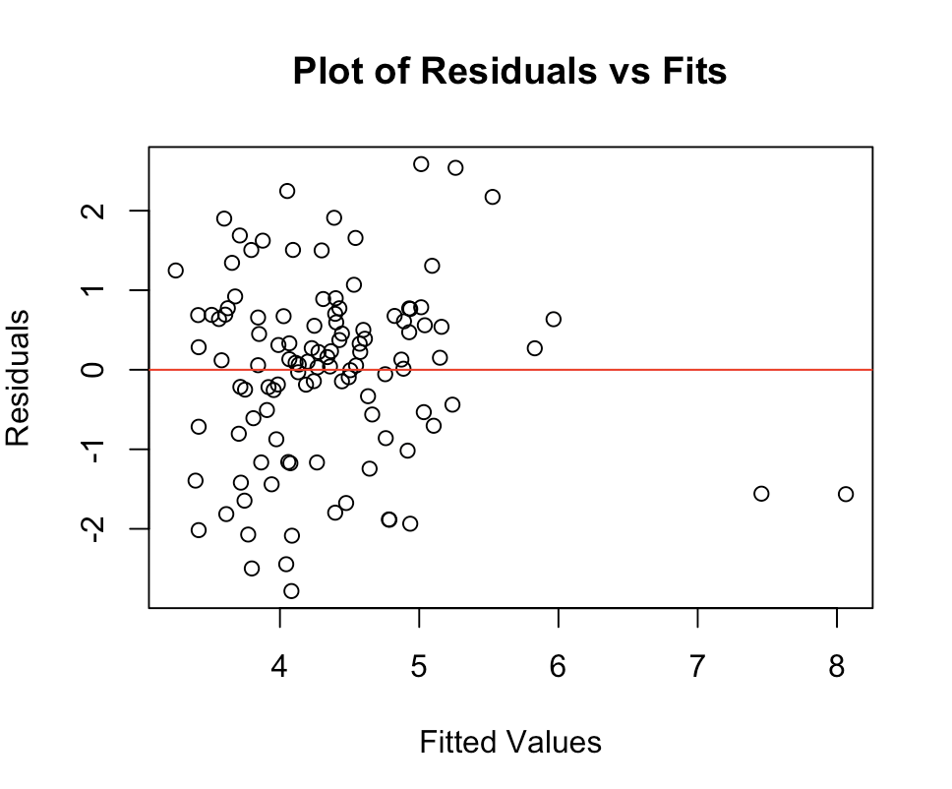

(c) The estimated slope is 0.37422.

(d) The $R^{2}$ is 0.2846.

(e) The following plots agree with the assumptions for a regression model.

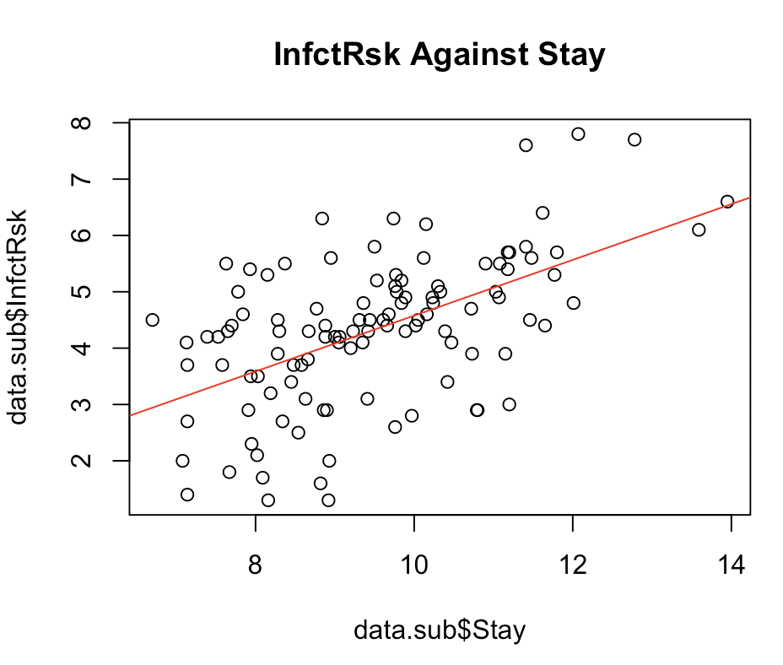 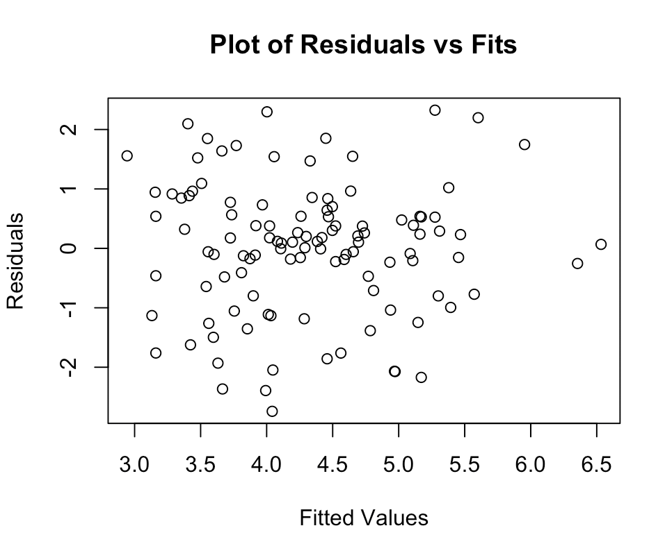

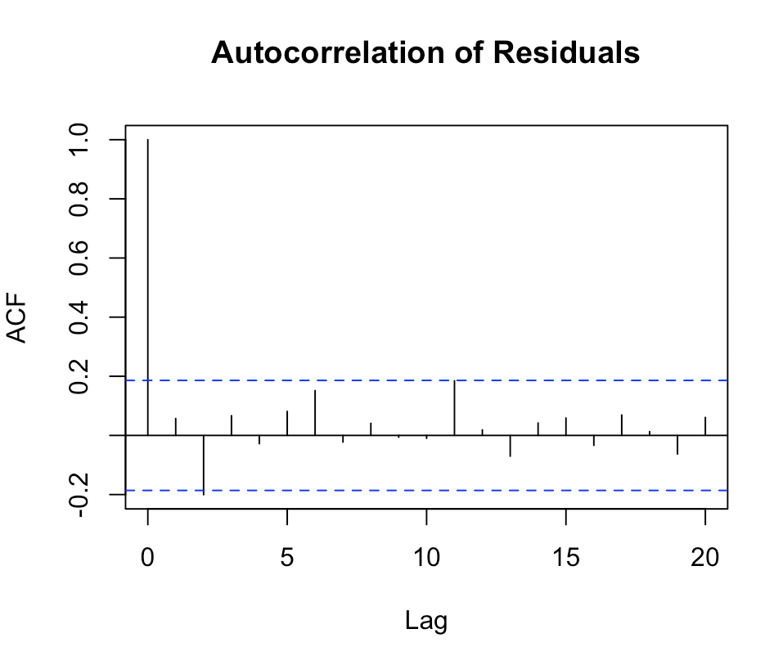 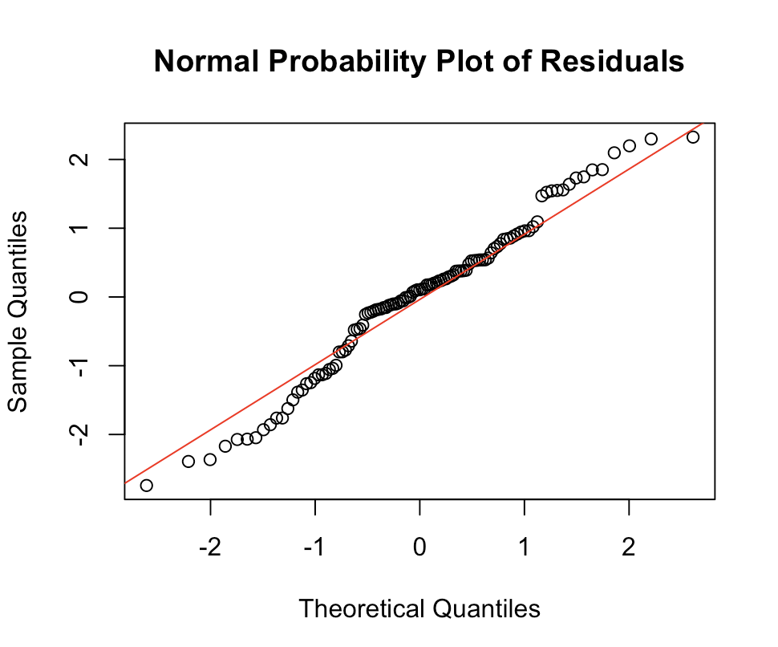

(f) The estimated slope is 0.49515, which is greater than the one from 1 (c).

(g) The $R^{2}$ is 3019, which is greater than the one from 1 (c).

(h) Overall, removing the outliers is a good step. The presence of outliers makes assumptions of regression model violated and leads to a lower determinant coefficient.